Introduction to Verilog RTL Design and Synthesis
I have gained hands-on knowledge of simulating Verilog codes using iVerilog and also worked on logic synthesis using Yosys.

Introduction:
Simulator: A simulator is a software tool that checks your digital circuit’s functionality by applying test inputs and viewing outputs. This helps you verify your design before hardware implementation.
Design: The design is your Verilog code describing the intended logic functionality
Testbench: A testbench is a simulation environment that applies various inputs to your design and checks if the outputs are correct

Simulating 2x1 Multiplexer:
Step 1: Install Required Tools
sudo apt install iverilog
sudo apt install gtkwave
Step 2: Simulate the Design
Compile the design and testbench: iverilog simple_mux.v tb_simple_mux.v
Run the simulation: ./a.out
View the waveform: gtkwave tb_simple_mux.vcd
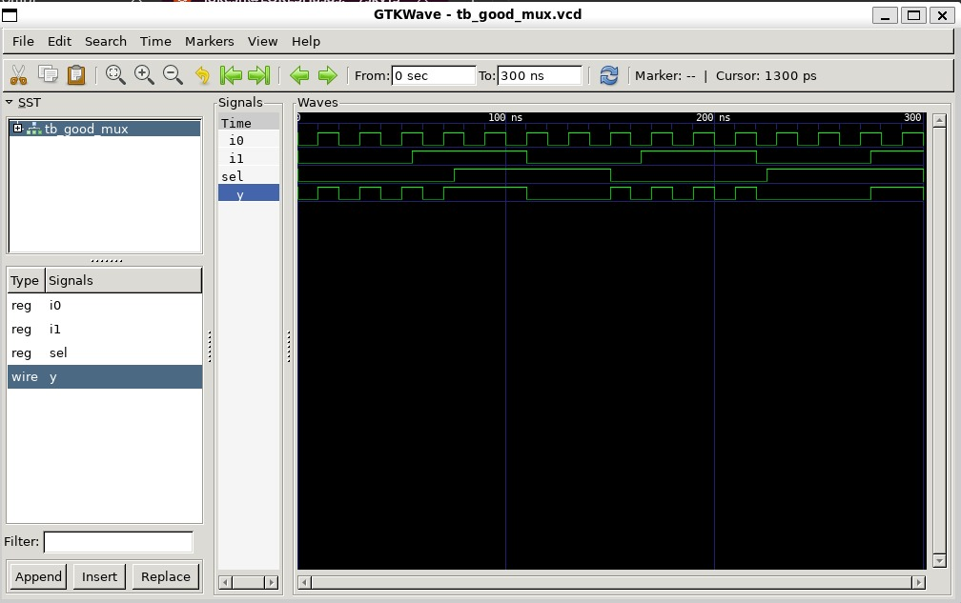

Verilog Code Analysis:
module simple_mux (input i0, input i1, input sel, output reg y);
always @ (*)
begin
if(sel)
y <= i1;
else
y <= i0;
end
endmodule

Introduction to Yosys:
Yosys is a powerful open-source synthesis tool for digital hardware. It takes your Verilog code and converts it into a gate-level netlist.

Synthesis with Yosys:
- yosys
- read_liberty –lib /address/to/your/sky130/file/sky130_fd_sc_hd__tt_025C_1v80.lib
- read_verilog /home/address/to/verilog/file
- synth -top simple_mux
- abc -liberty /address/to/your/sky130/file/sky130_fd_sc_hd__tt_025C_1v80.lib
- show

